Hand Refractometer Instructions Operating

SERIES
Style | Model | Range | Resolution | Size | Weight
Salinity/ATC | REF 211 | 0-100‰;  1.000~1.070 sg | 1‰; 0.001 | 29x40x190mm | 220g

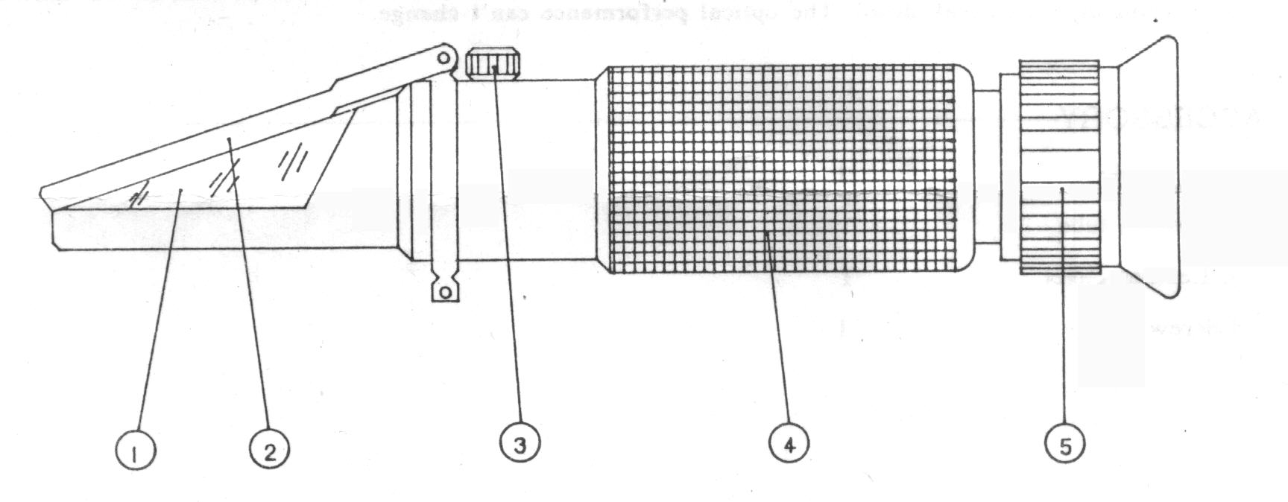
NAME OF COMPONENTS

1. Prism 2.Cover plate 3.Correct screw 4.Mirror tube 5.Eyepiece (Adjusting ring of diopter)

METHOD OF OPERATION
- Aim the front end of the refractometer to the direction of bright light, and adjust the adjusting ring of diopter 5 until the reticle can be seen clearly.
2. Adjustment of null
Open the cover plate 2, drop distilled water one or two drops on the surface of the prism. Cover the cover plate, rotate and adjust the correcting screw 3 to make the light/ dark boundary coincide with null line.
(Salinity/ATC Model should adjust at 20℃ environmental temperature)
- Open the cover plate 2 and clean the water on the prism and cover plate by soft cotton flannel, then drop one or two drops liquid which is needed to be checked on the prism surface and cover the cover plate. The corresponding dial reading of the light/dark boundary can get the percent of the salt content of the liquid.
- The carved line on the left of scale indicates the specific gravity of the sodium chloride liquor.
- After measurement, please clean directly the liquid which had been measured on the surface of prism by soft cotton flannel. After drying, please keep appropriately in store.

ATTENTIONS AND MAINTENANCE
- Adjust the null liquid and specimen should be under the same temperature, if the temperature varied greatly, the null point should be adjusted once per 30 minutes.
- After usage, don’t use water to wash the instrument.
- As it is a kind of precision optical instrument, you should hand it gently and take good care of it. Don’t touch and scratch the optical surfaces. It should be kept in the environment of dry, clean and non-corrosiveness air, so as to prevent the surface of it turning mouldy and foggy. Please avoid strong shock during transportation.
- If the consumers use the instrument in accordance with the mentioned method of usage, it guarantee that instrument can’t break down. The optical performance can’t change.

